Inventory Training and I-Tree Participant Packet

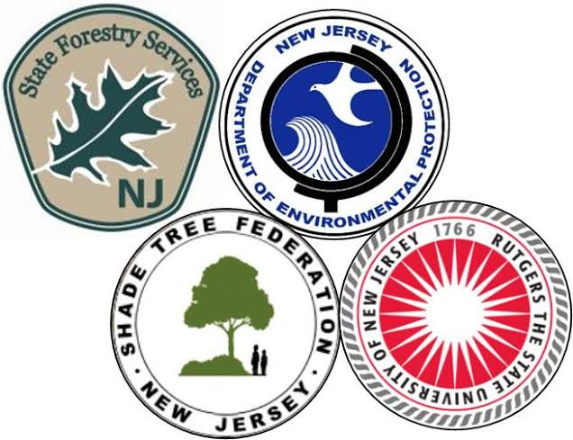

New Jersey Shade Tree Federation
Annual Conference
October 24th-25th, 2014
Cherry Hill, NJ
NJSTF Inventory Training and i-Tree Goals

- This program is intended to prepare participants to design and conduct a volunteer municipal street tree inventory.
- We will stress the need to understand the data you are collecting and what it means to your inventory.
- We will stress the need to be reasonable and realistic about the data you plan to collect and the importance of knowing what each piece of data collected will be used for.
- We will discuss the uses and limitations of i-Tree and how to design your inventory to be compatible.

Utilizing what you learn through this program, and with ongoing support from the NJ Shade Tree Federation/ Rutgers University/ NJDEP State Forestry Services partnership, we encourage you to:
- Conduct a street tree inventory for your municipality and use it to inform your planning, budgeting, and tree care decisions regarding the community tree resource.
- Complete a specific problem inventory of all ash trees in your municipality to help build a risk map for emerald ash borer in New Jersey’s urban and community trees.
- Complete a pre-storm assessment using the i-Tree Storm utility in order to better prepare your municipality for future storm events.
- Share al this data with each other and with the NJSTF/ Rutgers University/ NJDEP partnership.

Most importantly, we want to help you meet your goals and fulfill your needs. Please participate, please ask questions, and please let us know is there is something we can do to make this time more productive for you!

